RF Controlled Spy Robot with Night Vision Camera

This system uses RF remote controlled vehicle which has a camera that will be needed for spying purposes. The system proves to be very beneficial in places where humans cannot be sent for spying purposes such as military places as there can be some risk involved. The vehicle in this system has a night vision enabled camera. This vehicle can be operated wirelessly using RF remote.
Here the camera send signals to the receiver used and the place that will be captured by the camera can be displayed remotely on a PC and can be recorded for further reference. In this system we use 8051 microcontroller in order to control the system which will be interfaced to the receiver.
In this both the RF remote and the vehicle is battery powered. As the user sends commands through RF remote using the push buttons on the remote, these commands are then sent to the receiver. The receiver then sends these commands to microcontroller which processes these commands which determines in which direction the vehicle moves. The RF remote has 4 push buttons for forward, backward, left and right which will make the vehicle move in the direction specified.

Block Diagram:

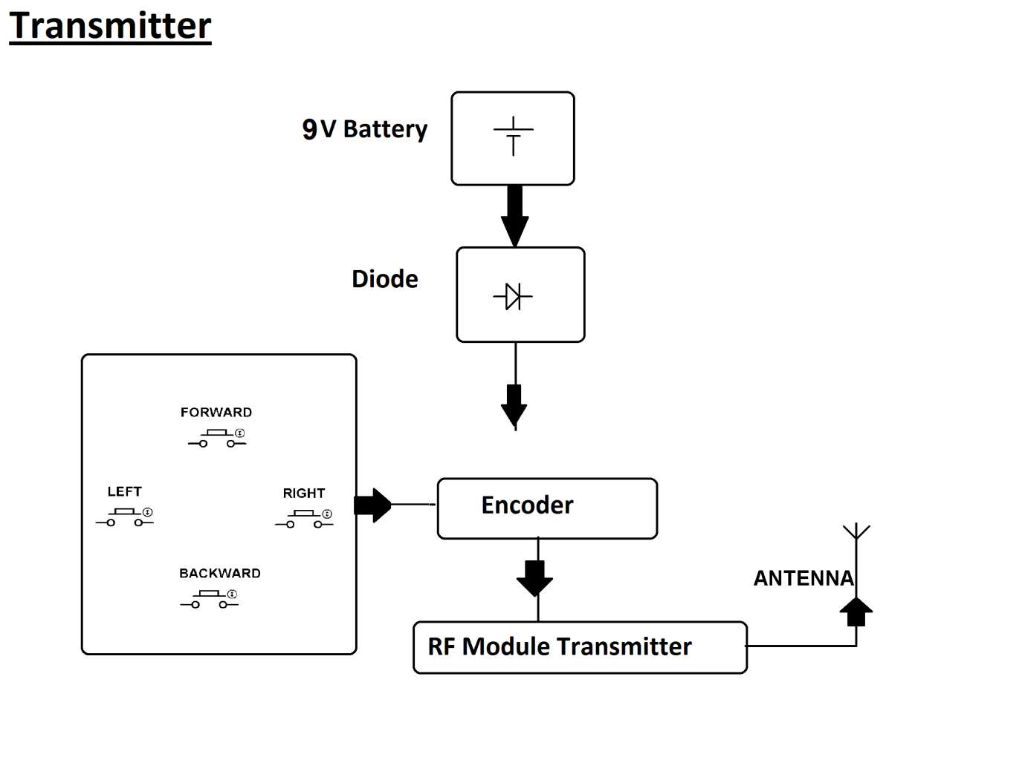
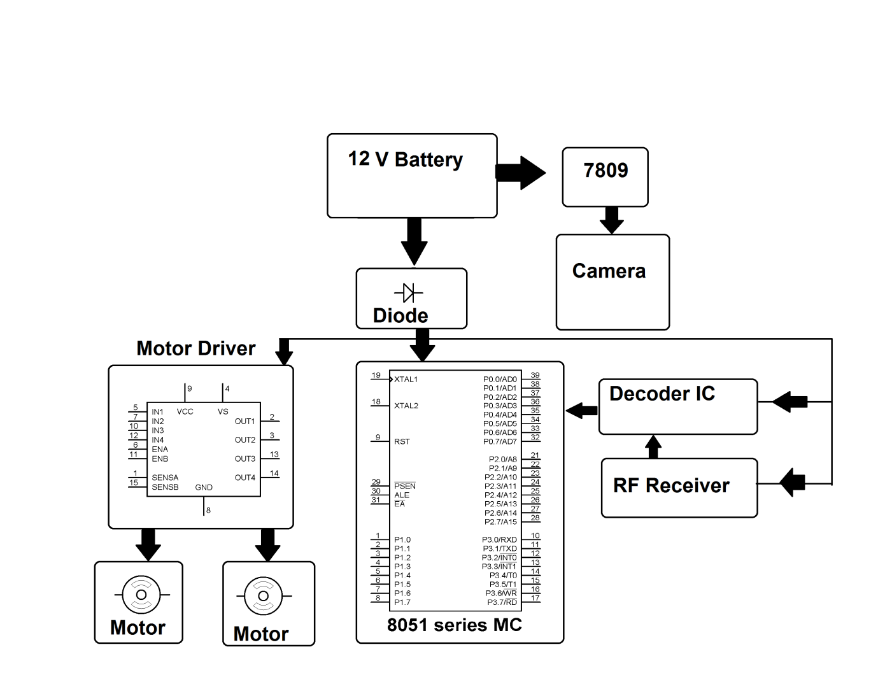

Hardware Specifications
- 8051 series Microcontroller
- Night vision camera
- Push Buttons
- RF module
- Encoder
- Decoder
- 7809IC
- Motor driver IC
- DC motors
- Batteries

Software Specifications
- Keil µVision IDE
- MC Programming Language: Embedded C

RF Communication Module
RF communication works by creating electromagnetic waves at a source and being able to pick up those electromagnetic waves at a particular destination. These electromagnetic waves travel through the air at near the speed of light. The wavelength of an electromagnetic signal is inversely proportional to the frequency; the higher the frequency, the shorter the wavelength.
Frequency is measured in Hertz (cycles per second) and radio frequencies are measured in kilohertz (KHz or thousands of cycles per second), megahertz (MHz or millions of cycles per second) and gigahertz (GHz or billions of cycles per second). Higher frequencies result in shorter wavelengths. The wavelength for a 900 MHz device is longer than that of a 2.4 GHz device.
In general, signals with longer wavelengths travel a greater distance and penetrate through, and around objects better than signals with shorter wavelengths.
RF Module can be categorized into two parts:
- Transmitter
- Receiver

2. RF transmitter
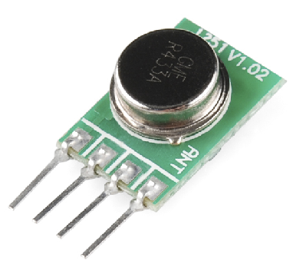
This wireless data is the easiest to use, lowest cost RF link we have ever seen! Use these components to transmit position data, temperature data, and even current program register values wirelessly to the receiver. These modules have up to 500 ft range in open space. The transmitter operates from 2-12V. The higher the Voltage, the greater the range. We have used these modules extensively and have been very impressed with their ease of use and direct interface to an MCU. The theory of operation is very simple. What the transmitter 'sees' on its data pin is what the receiver outputs on its data pin. If you can configure the UART module on a uC, you have an instant wireless data connection. The typical range is 500ft for open area.
This is an ASK transmitter module with an output of up to 8mW depending on power supply voltage. The transmitter is based on SAW resonator and accepts digital inputs, can operate from 2 to 12 Volts-DC, and makes building RF enabled products very easy.
Features:
- 434 MHz or 315 MHz Transmitter Operation
- 500 Ft. Range - Dependent on Transmitter Power Supply
- 2400 or 4800bps transfer rate
- Low cost
- Extremely small and light weight

RF receiver
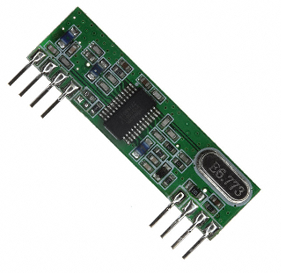
This receiver type is good for data rates up to 4800bps and will only work with the 434MHz o 315 MHz transmitter. Multiple 434MHz or 315MHz receivers can listen to one 434MHz transmitter or 315 MHz transmitter. This wireless data is the easiest to use, lowest cost RF link we have ever seen! Use these components to transmit position data, temperature data, and even current program register values wirelessly to the receiver. These modules have up to 500 ft. range in open space. The receiver is operated at 5V. We have used these modules extensively and have been very impressed with their ease of use and direct interface to an MCU. The theory of operation is very simple. What the transmitter 'sees' on its data pin is what the receiver outputs on its data pin. If you can configure the UART module on a uC, you have an instant wireless data connection. Data rates are limited to 4800bps. The typical range is 500ft for open area. This receiver has a sensitivity of 3uV. It operates from 4.5 to 5.5 volts-DC and has digital output. The typical sensitivity is -103dbm and the typical current consumption is 3.5mA for 5V operation voltage.
Features:
- 434 MHz or 315 MHz Operation
- 500 Ft. Range - Dependent on Transmitter Power Supply
- 4800 bps transfer rate
- Low cost
- Extremely small and light weight

